Name: Rainjie Llorca
Position: Full Stack .Net Developer

EmsiSoft Coding Challenge documentation

This documentation will guide you on how to test these projects ExamAPI and BackgroundWorker. It includes database setup and testing

ExamAPI project

1. In ExamAPI foler open the project EmsiSoftExam.sln
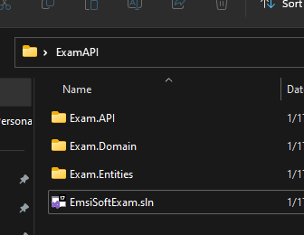

2. Inside the solution expand “Exam.API” project then open the file “appsettings.json”
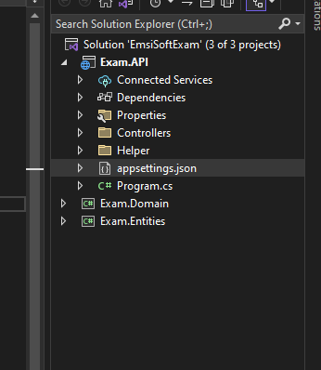

3. Change the server name in the ExamConnection, just replace the SQLDEVELOPER or put you sql server name

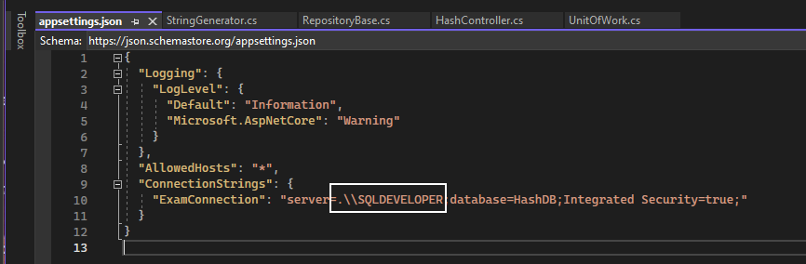

4. In the Package Manager Console select the “Exam.Entities” as Default Project
Note: to open the Package Manager Console, In the menu click View > Other Windows > Package Manager Console

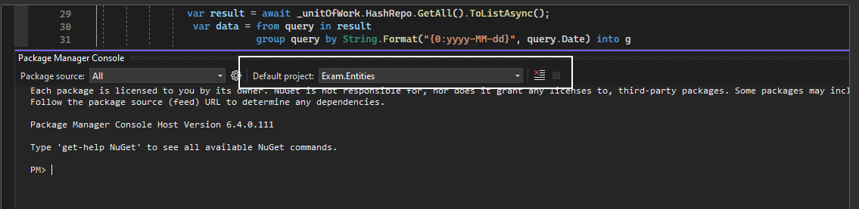
5. Let’s clean the existing Migration, to do so just type Remove-Migration in Package Manage Console and press Enter

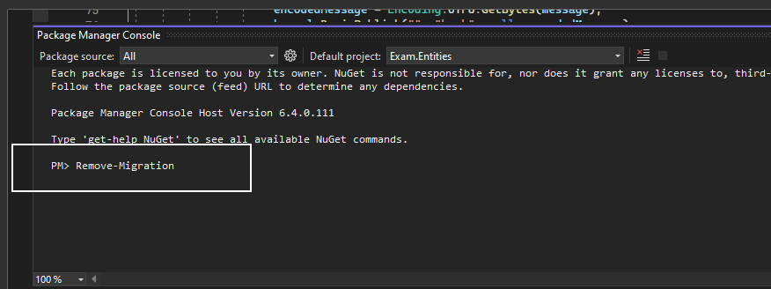

You should see Build Succeeded

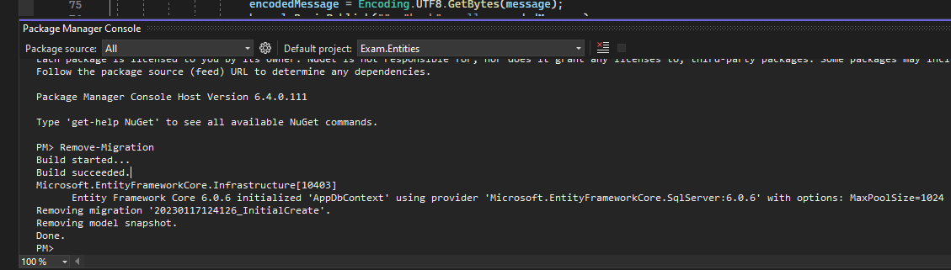

Creating the Database

1. In Package Manager Console type Add-Migration {Name}, in my case I put Add-Migration InitialCreate

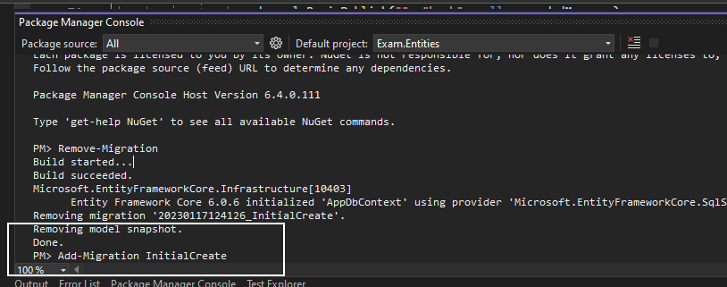

The Build should succeed and you should see a new file

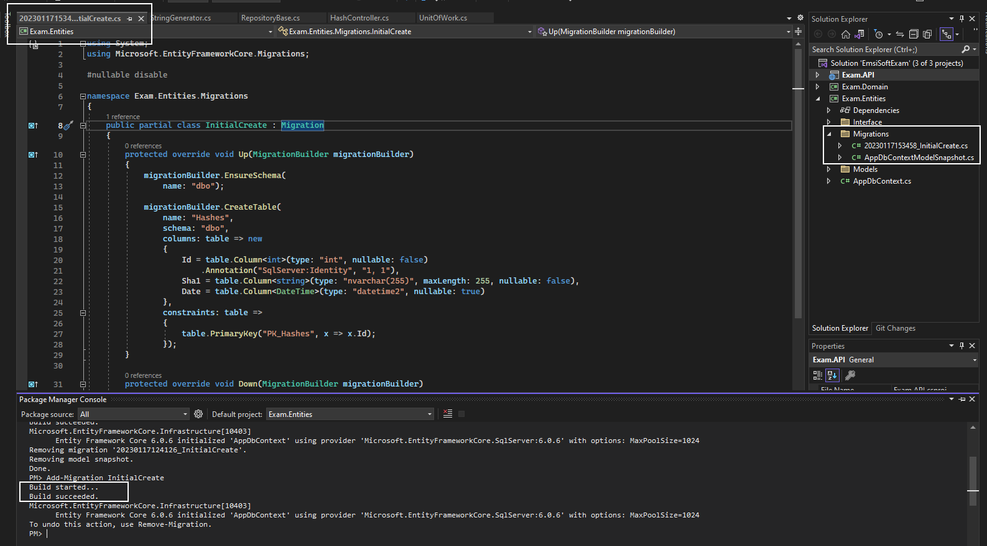

2. In Package Manage Console type Update-Database and press Enter

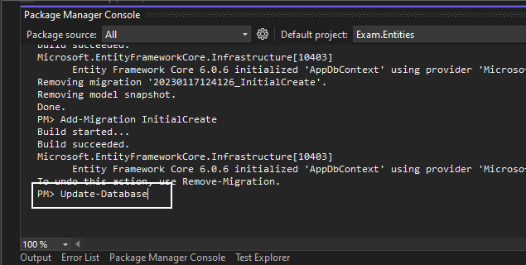

The build should be Done

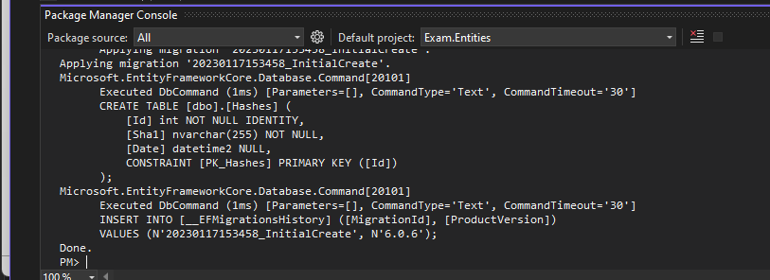

A new database should be created in sql server

BackgroundWorker project

Set the database connection

1. Open the BackgroundWorker Project and open the Program.cs file
change the SQLDEVELOPER to your sql server name

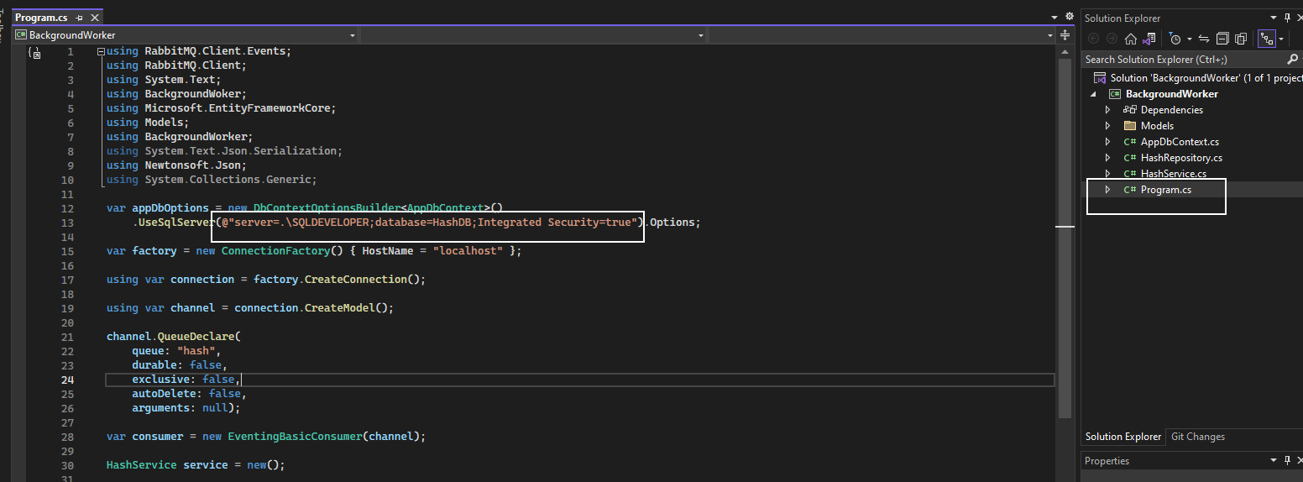

Testing

1. Run the ExamAPI project and you should see swagger page
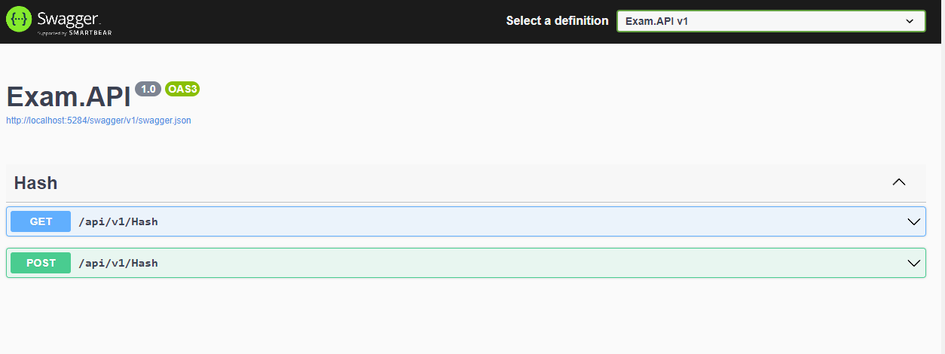

2. Expand the POST panel and click the Try it out, you should see an Execute button

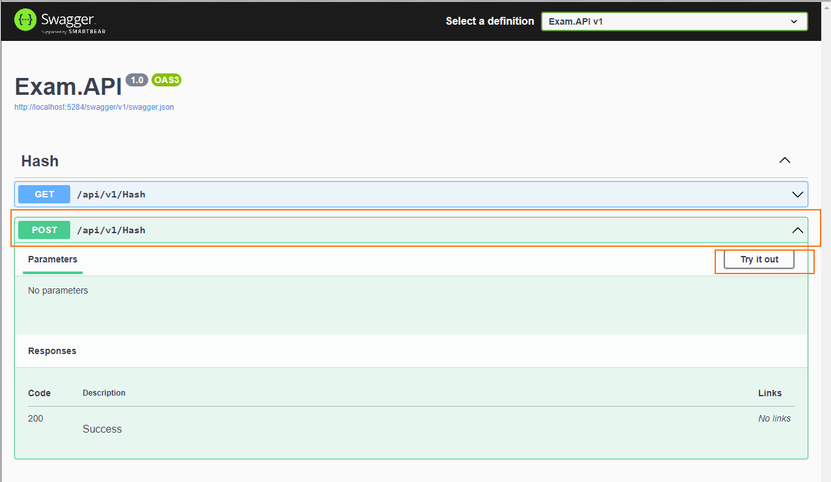

After executing the POST method, you should see a message “Message Sent”

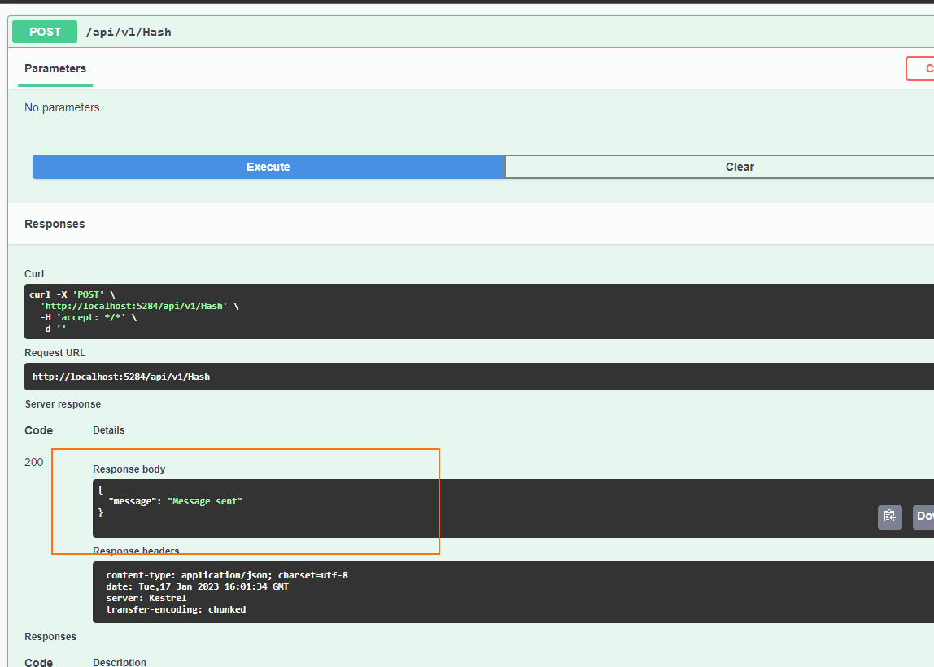

In my RabbitMQ will receive a message and put it in queue

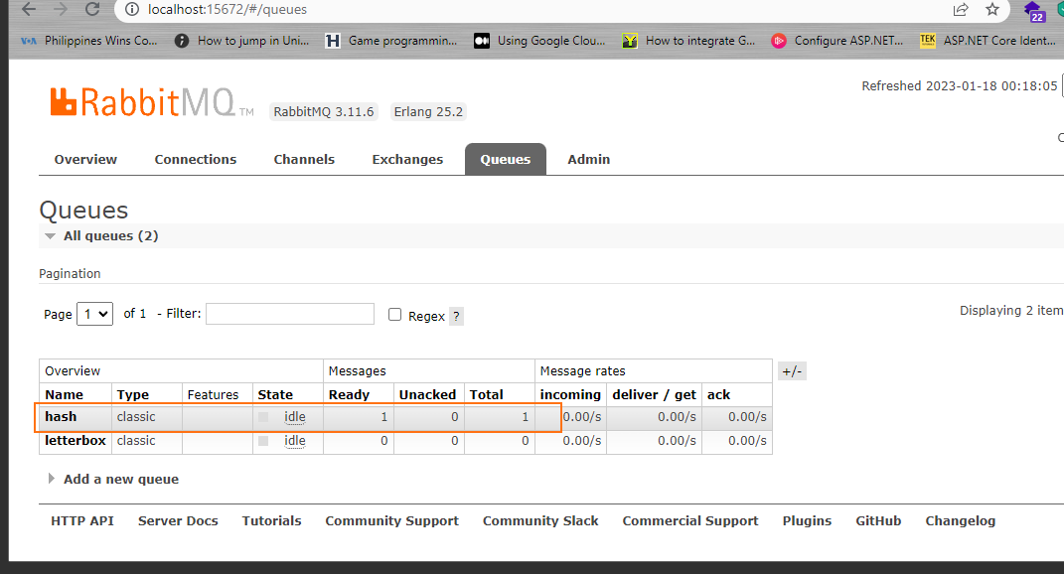

3. In the BackgroundWoker Console App, it should return a message “Received new message”.
It means the hash are saved to the database.
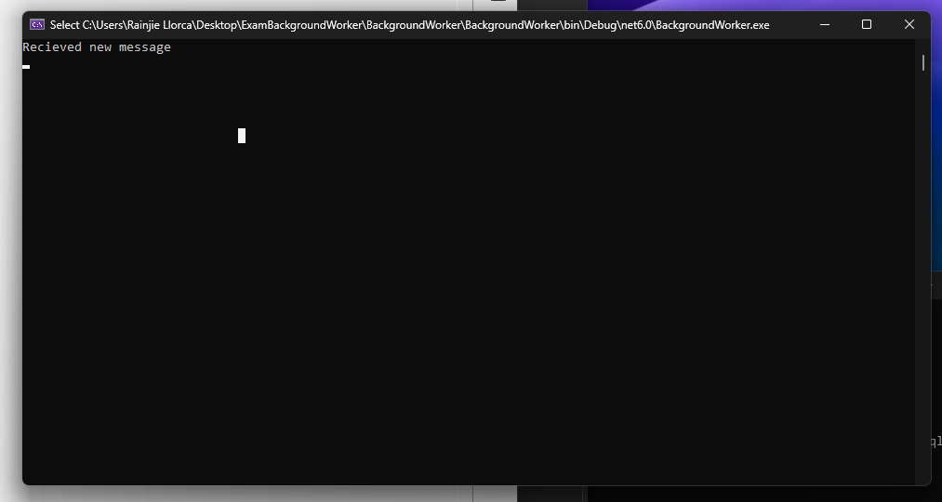

In my case, I tested it 3 times that’s why I get 3000 records

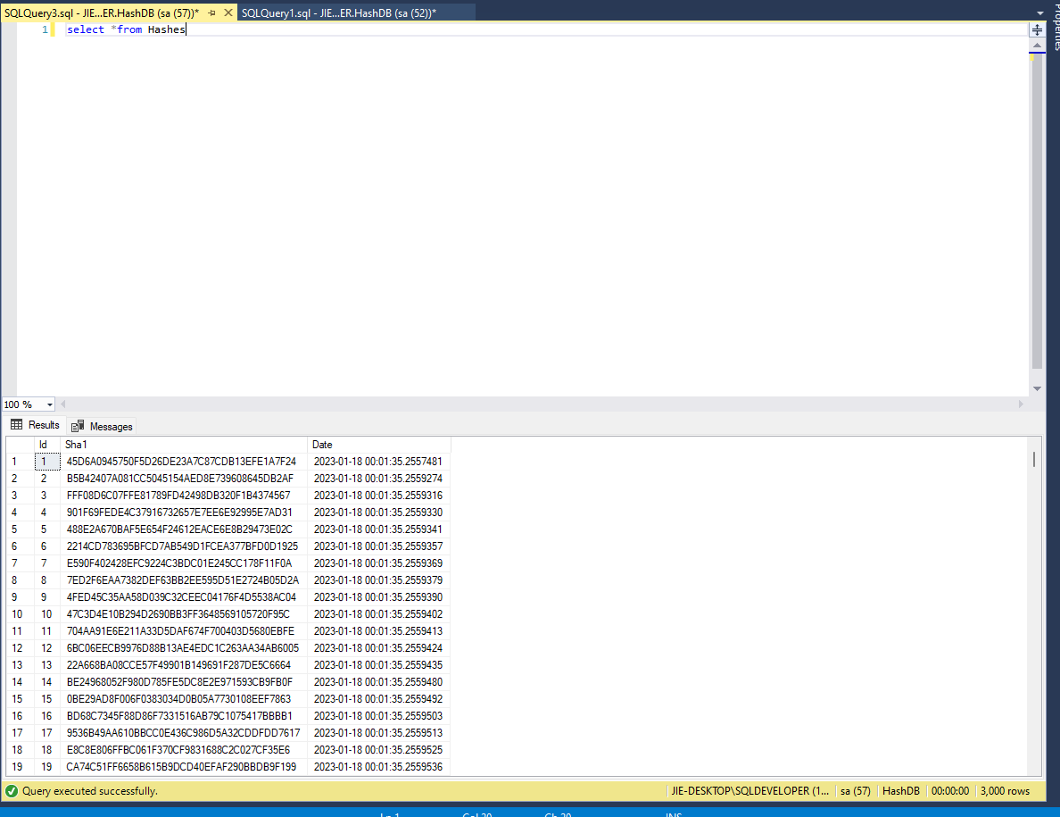

4. Get the number of data using API. In swagger page expand the GET panel and click the Try it out button

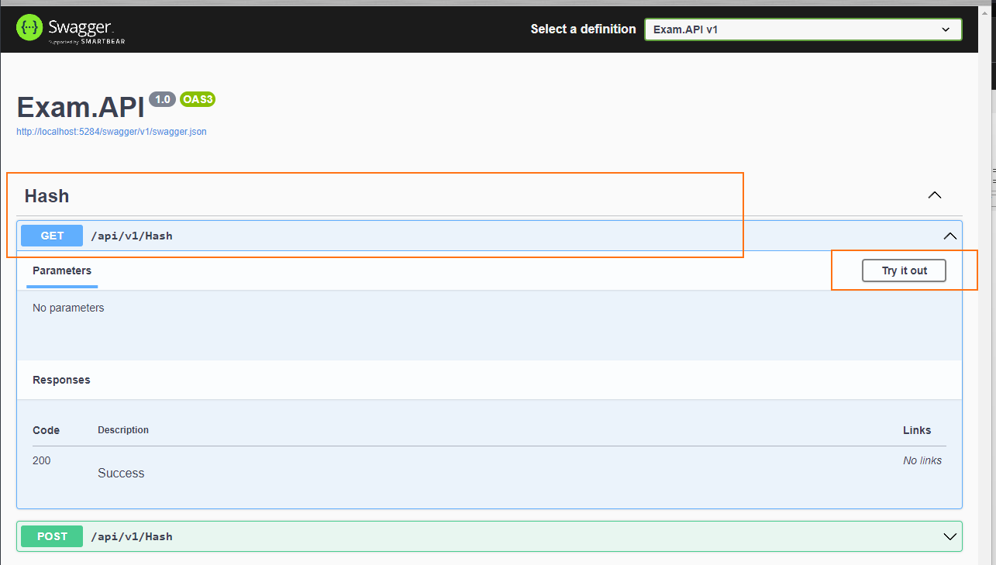

and more example

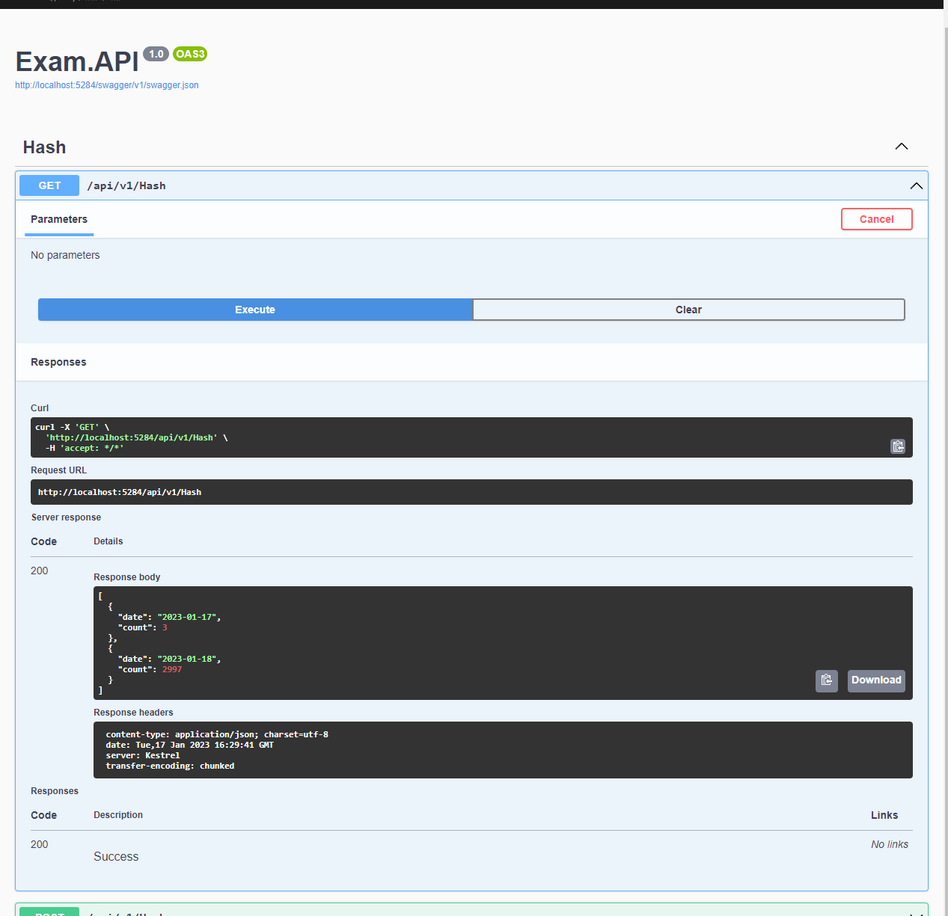

You should see Execute button. After you clicked the button it should return a response data, the number of Hash grouped by day

